ECM3432DA Software Engineering 1

Agile Development Exercise

Student ID: 730087020

Word Count
Section | Count
1. Introduction | 532
2. KSB Progress Table | 2064
3. Reflective Analysis | 2653
Total | 5249

Word Count 0
1. Project Overview 1
1.1. Outline 1
1.2. Objectives 1
2. Artifacts 2
2.1. Statement of Requirements 2
Functional 2
Non-Functional 2
2.2. Software Architecture 3
Client-Server Pattern 3
Server Architecture Design 3
Client Architecture Design 3
2.3. Client UI Design 3
2.4. Software Release 3
3. Process 5
Requirements Engineering 5
Appendix 6

1. Project Overview

1.1. Outline
This project proposes a new social platform, Community Tourist Assistant.
Community Tourist Assistant will allow visitors to the region to identify interesting places and activities.
Information on the platform will be crowd sourced by locals and tourists alike.

The proposal is formed of the following:
- Statement of requirements that must be met by the solution
- Software architecture recommendation
- Software User Interface (UI) design
- Minimum Viable Product (MVP) prototype

1.2. Objectives
- Centralise tourist information.
- Reduce the overhead for stakeholders of local tourism.
- Encourage profitable tourism through community engagement, such as ratings.
- Increase the length of time visitors stay, by presenting a wide range of sites and activities.
- Publicise niche and ever-changing tourist attractions in a scalable manner.

2. Artifacts

2.1. Statement of Requirements

Functional
Epic | User Story | Delivered
 |  | Sprint 1

Non-Functional
Category | Sub-Category | Requirement
Product | Performance
Product | Reliability
Product | Security
Product | Usability
Organisational | Operational
Organisational | Development
External | Regulatory
External | Ethical

2.2. Software Architecture

Client-Server Pattern

Server Architecture Design

Client Architecture Design

2.3. Client UI Design

2.4. Software Release

Timeline:
- Requirements Engineering
  - Personas
  - Epics
  - User stories
  - Non-functional
- Review of Software Assets
- Software Architecture Design
  - Server Architecture Design
  - Client Architecture Design
- Client UI Design
- Development & Testing
  - Initial backlog & Sprint 1 planning – kanban update
  - Sprint 1 dev & testing, Sprint 1 retro, Sprint 2 planning – kanban update
  - Sprint 2 dev and testing, Sprint 2 retro, Sprint 3 planning – kanban update
  - Sprint 3 dev and testing, Sprint 3 retro, Sprint 3 planning – kanban update
  - Sprint 4 dev and testing, Sprint 4 retro – kanban update
- Demo

3. Process

Requirements Engineering
January 16



User Personas


Tourist
Goals
- To identify interesting places and activities by viewing place details, photos and ratings
- To contribute ratings and photos
- To collect badges
Local
Goals
- To contribute place photos
- To report incorrect place details
- To report unrelated photos
Administrator
Goals
- To manage user accounts
- To manage and act upon reported place details and photos
- To encourage contribution, such as by assigning badges

Epics
- Scrollable ‘Places’ page
- ‘Place’ details page
- ‘Sign Up or Log In’ page
- ‘Upload’ page
- ‘My Badges’ page
- ‘Manage Accounts’ admin page
- ‘Manage Places’ admin page

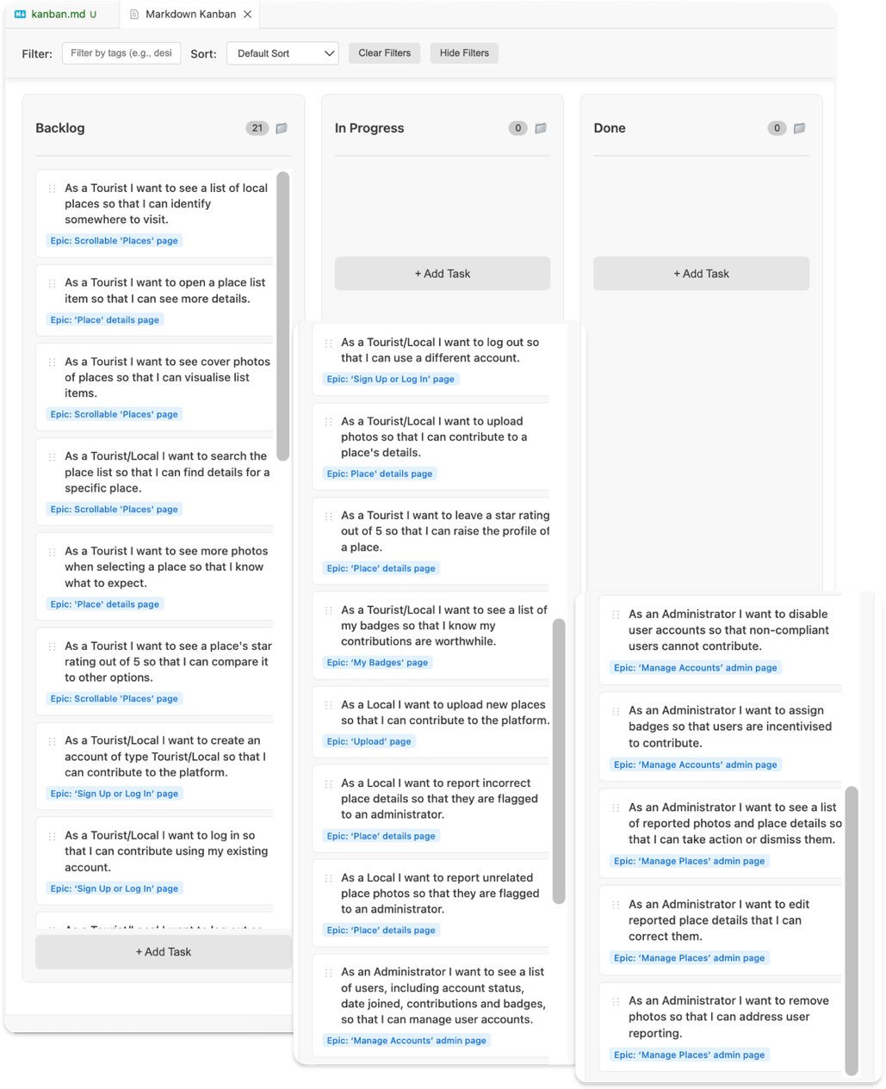
Initial Backlog
January 23

Appendix
Invalid source specified.

